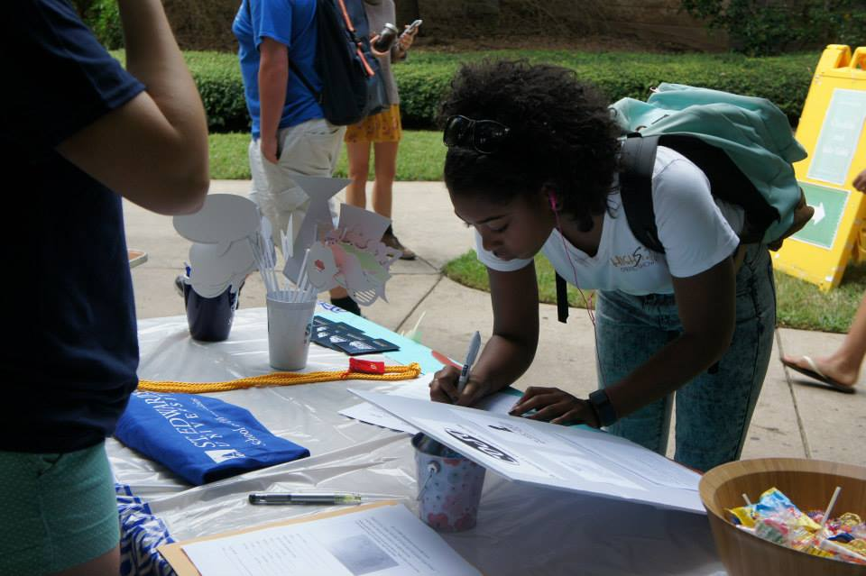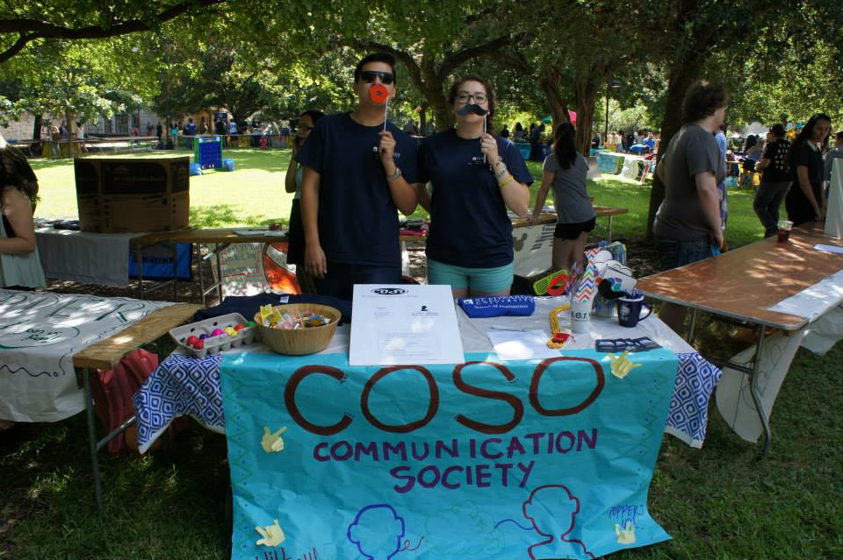

**COMMunity Meetings**

Come find out what it really takes to communicate through your major.

We aim to communicate to our society through service.

Communication

Society

COSO

Follow me to Page

Is Communication Society For Me?

September 2015

"Take advantage of every opportunity to practice your communication skills so that when important occasions arise, you will have the gift, the style, the sharpness, the clarity, and the emotions to affect other people."

* Jim Rohn

As students of St. Edward’s University, we have a duty to our community, to our peers, and ourselves to use the skills we learn as young leaders in this institution to take on our world. We are here to create change and bring awareness to moments of history to which we are a part of. As members of Communication Society, we will reign together with our power of communication to demonstrate the capacity of a united group of individuals.

## Toppers for a Cause

**St. Jude Walk/Run**

Walk. Run. Join Our Fight.

SEU_COSO is taking a stand against childhood cancer. Are you ready to join the fight?

Inside

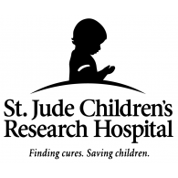

**Donate Now!**

**Stjude.org/walkrun**

Join the SEU Groovy Goats

September is National Childhood Cancer Awareness Month, making this the perfect time to rally our friends, family, and community to support the research and work done in order to save children with cancer of St. Jude Children’s Research Hospital. As members of Communication Society, we have the privilege of having a united group of students that want to create changes for a better future. We are capable of reaching so many lives with our actions and voices; a walk/run for St. Jude Children’s Research Hospital is only the commencement to a very active academic year for all parties involved. I, Ruby Leon, President of COSO invite you to take on your world and show the Austin Community we are working one mile at a time towards a stronger future. Sign up in four simple steps:

* Register under our team name: SEU_COSO
* Form our Team:

Invite friends, family, co-workers, and neighbors to join our cause and fundraise with us.

* Fundraise:

Help each other promote our cause on social networks! If you have promotion ideas, email me a.s.a.p.! ([rleon@stedwards.edu](mailto:rleon@stedwards.edu))

* TAKE ACTION!

We celebrate our commitment at the *St. Jude Walk/Run to End Children Cancer* on Saturday, September 26.

### GO THE EXTRA MILE

### *Be Fearless! Be Active! Join the Fight!*

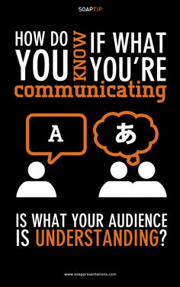

**What is NCA?**

The National Communication Association advances Communication as the discipline that studies all forms, modes, media, and consequences of communication through humanistic, social scientific, and aesthetic inquiry.

Natcom.org

##### Have you visited us at Collegiate Link?

##### Sign in to myhilltop

##### Click on Student Services

##### Click on Quick Links: Collegiate Link

##### ENJOY!

National Communication Association

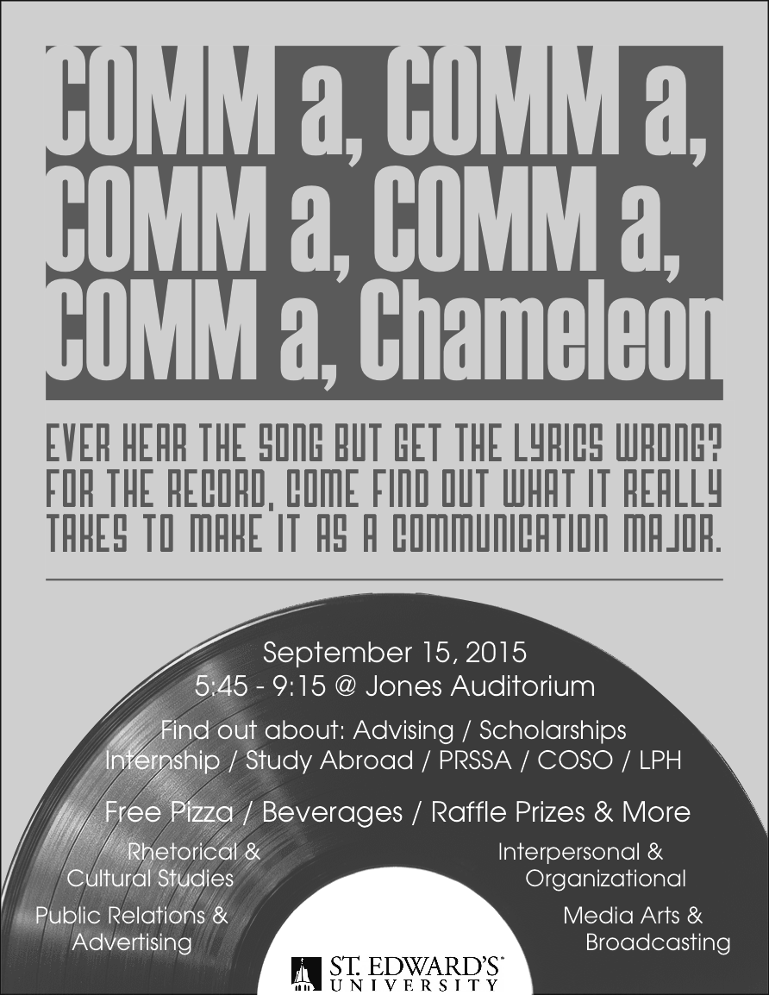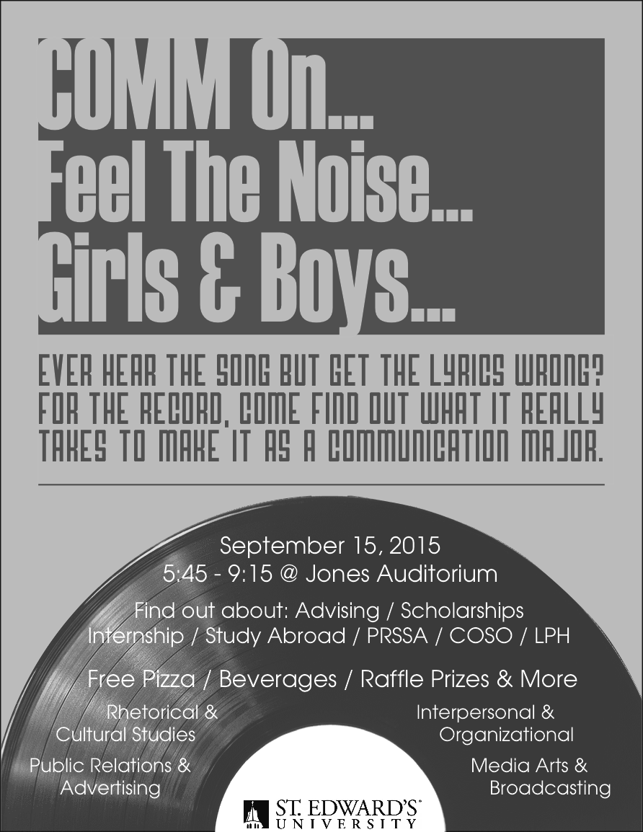

***Follow us on social media:***



[www.facebook.com/seucoso](http://www.facebook.com/seucoso)



@seu_coso



@coso_seu

**COSO** is a place to grow in self-discovery, self-value, and make a difference in forms of education.

**COSO** aims to create bridges between all majors of studies not only communication.

**COSO** bring all forms of communication in one atmosphere and bring value to successful interpersonal relationships.

Continued from page 1

9/15

Communication Meeting @ Jones Auditorium 5:45-9:15 PM

9/22

Student Organization Drive @ Fleck 305 5:45-9:15 PM

9/26

St. Jude Walk/Run @ Austin Park n’ Pizza Experience

9/29

COSO First Official Members Meeting

Main Building 320

**Don’t forget the first COMMunity Meeting! We will be discussing all aspects of being a Communication major as well as upcoming academic and social events.**

(Continued) Can you hear the music?

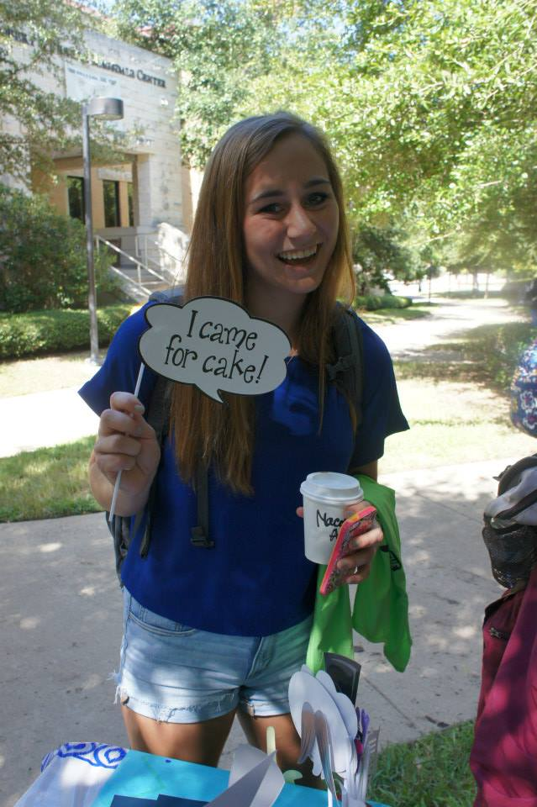

COSO wants YOU!

[Issue] :: [Date]

LoremIpsumDolor

As we said the day of Involvement Fair, we are an organization for the university and aspire to reach more than just communication majors at St. Edward’s University. Here at the hilltop, we want to work towards communicating with the community through service. SEU Communication Society offers three levels of involvement: academic, professional, and social. Come one, come all!!! We cannot wait to see you all!!!



Let’s Go Hilltoppers!!

Ruby Leon

Communication Society President

St. Edward’s University

[rleon@stedwards.edu](mailto:rleon@stedwards.edu)

(832) 798-8691

We aim to communicate to our society through service.

COSO

St. Edward’s University